Distressed or in Crisis?
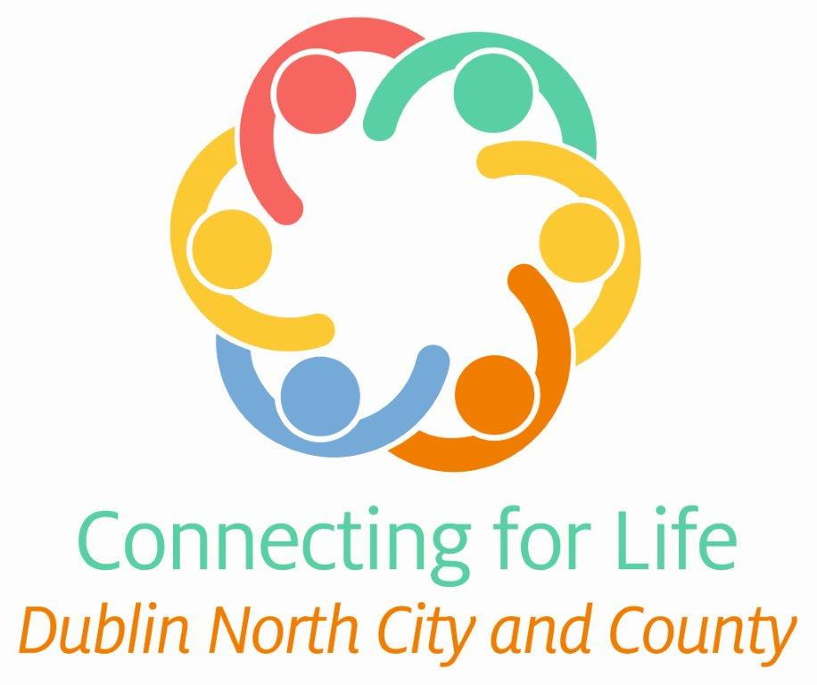
You are not alone, help is at hand
Talk to your GP or Samaritans
Your GP can make referrals to specialist services and also give you information about the supports available in your area.
Emergency Services | Garda Síochána, National Ambulance Service, Fire Service and Irish Coast Guard | 112 or 999
D-Doc | Urgent out of hours GP care | 1850 22 44 77
24 HOURS A DAY | 7 DAYS A WEEK
Emergency Departments | Beaumont Hospital | 01 809 3000
 | Connolly Hospital | 01 646 5000
 | Mater Hospital | 01 803 2000
 | Children’s Health Ireland at Temple Street | 01 878 4200
Samaritans | Emotional support service (branch visits closed) | 116 123 (helpline) or jo@samaritans.ie
Pieta | Pieta House provides telephone and text-based support counselling for people who are suicidal or engaging in self-harm. Telephone appointments will be provided to replace face to face appointments – contact your local Pieta for details. | 1800 247 247  Pieta Collins Avenue: 01 884 0532  Pieta Dublin North: 01 883 1000  www.pieta.ie
Childline | Confidential phone line for children and young people | 1800 666 666  Text ‘Talk’ to 50101 (10am-4am)  www.childline.ie
Crisis Text Line Ireland | A confidential 24 hour messaging support service. | Text ‘TALK’ to 086 1800 280
Counselling and other supports
Turn 2 Me (Over 18s) | Free online counselling and online support groups for people over 18 | www.turn2me.org
My Mind | Online counselling service | www.mymind.org or email hq@mymind.org
Jigsaw | Mental health information and a Q&A service for young people (12 – 25), their parents and guardians, and those who work with young people. Jigsaw also offers an online group chat service and daily Instagram live information sessions taking place at 3pm. | 01 960 3020 (North Fingal)  01 890 5810 (Dublin 15)  01 658 3070 (Dublin City)  www.jigsawonline.ie
Shine | Shine are currently providing remote support and an outreach service to people experiencing mental health problems and their families and supporters by phone and email. | 01 860 1620 (Resource Centre)  086 0142 112 (Information Support Officer)  east@shine.ie / phil@shineonline.ie  counsellingdublin@shine.ie
Suicide or Survive (SOS) | Free online wellness workshops and programmes available from SOS | www.suicideorsurvive.ie
What’s Up BRYR Counselling service | Counselling service for young people in the Ballymun area. Face to face services are closed; phone, text and online supports available. | 01 8667 600  www.bryr.ie
Fingal Counselling Service | Offers a safe and confidential counselling service. Face to face service closed. For urgent support, please ring and leave a message and a counsellor will be in contact with you. | 01 890 2596  www.counsellingatfingal.com  info@counsellingatfingal.com
Genesis Therapy | Provides professional, low cost, community based therapy and support to Dublin 15. Face to face and phone services are available. | 01 820 2764  www.genesistherapy.ie
Target Counselling | Telephone service offering confidential, one to one non directive counselling. This service is offered by counsellors trained to listen support and counsel; bereavement support service also available. | 01 867 0279  www.targeteducation.ie
Northside Counselling Service | Provides a professional voluntary and community based counselling service. Telephone/video counselling support available. | 01 848 4789
CAMHS | Provides assessment and treatment for young people and their families who are experiencing moderate to severe mental health difficulties. Due to COVID19, CAMHS is only taking on urgent cases that must have a GP referral. | www.hse.ie/CAMHS
GROW Mental Health Recovery | Provides support around emotional and mental wellbeing. Information line operating as normal. | 1890 474 474  info@grow.ie  www.grow.ie
Teenline | Confidential phone line for teenagers. As of March 13th the helpline is operating between 6-9pm every evening. | 1800 833 634  Text TEEN to 839863  www.teenline.ie
Spunout.ie | An interactive online community where young people (16-25) are empowered with the information they need to live happy, active and healthy lives. | 086 1800 280  www.spunout.ie
Exchange House Ireland National Traveller Mental Health Service | Provides Traveller specific mental health and suicide prevention services. Face to face and group services closed, telephone and online services are still available. | 01 872 1094  www.exchangehouse.ie  info@exchangehouse.ie
Traveller and Roma Covid-19 Helplines | These are information helplines specifically for the Traveller and Roma community with questions /concerns in relation to Covid-19. | Travellers: Phone or text: 083 100 6 300  Roma: 087 126 4606
Traveller Counselling Service | A community based counselling service for the Traveller community. Phone and online counselling available. | 01 868 5761 or 086-308 1476  info@travellercounselling.ie
Bodywhys | The national voluntary organisation supporting people affected by eating disorders. Helpline operating Monday, Wednesday and Sunday from 7.30pm to 9.30pm and Saturday from 10.30am to 12.30pm) | 1890 200 444  www.bodywhys.ie  alex@bodywhys.ie
Aware Support Line | Listening service for people with depression or those concerned about a family member or friend. Phone-in support and self care groups available (register on aware.ie). Support line available Monday to Sunday from 10am-10pm | 1800 804 848 (free)  www.aware.ie  supportmail@aware.ie
Alone | Alone provide a COVID-19 support line for older people from 8am to 8pm, seven days a week | 0818 222 024  www.alone.ie
Seniorline | Confidential listening service for older people provided by trained older volunteers. Lines are open every day from 10am to 10pm). | 1800 804 591  http://www.thirdageireland.ie/seniorline
HSE Drug & Alcohol Helpline | This service provides a confidential Freephone helpline for information and guidance to services from Monday to Friday between 9:30am and 5:30pm | 1800 459 459  helpline@hse.ie
LGBT Ireland | National support service for Lesbian, Gay, Bisexual, and Transgender people and their families and friends. Face to face services are currently closed but an instant messaging service is available. | 1890 929 539  info@lgbt.ie
BeLonG To Text Support | Crisis Text Line available (anytime day or night, standard SMS rates may apply). While face to face services are closed, information, referral and advice will be provided digitally, by email, SMS, phone call or video conference | Text LGBTI+ to 086 1800 280  www.belongto.org
Practitioner Health | Confidential support and help for doctors, dentists and pharmacists | 01 2970396  confidential@practitionerhealth.ie
Bereavement Supports
Anam Cara | Provides information, resources and bereavement support after the death of a child of any age and through all circumstances to all bereaved parents. Parent evenings cancelled during April 2020. | 085 288 8888  www.anamcara.ie
Oasis – Deora Counselling | This is a specialised counselling and crisis intervention service working  with bereavement and suicide loss. Face to face services are closed, phone, online and SMS supports available. | 01 836 4524  info@oasiscentre.ie  www.oasiscentre.ie
Barnardos Children’s Bereavement Service | Information, advice and therapeutic support for bereaved children, young people and their families. Face to face services are closed. Helpline: Monday-Thursday between 10am-12pm. | 01 473 2110 (Helpline)  01 8134100 (Reception)  bereavement@barnardos.ie
HUGG-Suicide Bereavement  Peer Support Group. | Provide a safe, confidential environment in which those bereaved by suicide can share their experiences, feelings and gain support from others. Group meetings cancelled, online supports are available. | 01 513 4048  info@hugg.ie  www.hugg.ie
Friends Of Suicide Loss (FOSL) | This service offers educational programmes, workshops, presentations, lectures and resources for the suicide bereaved. Group meetings are closed, Skype, online and telephone support available. | 01 492 7476  www.friendsofsuicideloss.ie  info@fosl.ie
The Irish Hospice Foundation  www.yourmentalhealth.ie information and signposting on all mental health supports and services available nationally & locally provided by the HSE and funded partners.  Call (Freephone) YourMentalHealth Information line to find supports and services 18001188 (24 hours). | The Irish Hospice Foundation - a suite of materials available to inform, support and reassure people during the Covid-19 particularly in the area of bereavement and loss | 01 679 3188  https://hospicefoundation.ie/bereavement-2-2/covid19-care-and-inform/

