## http://www.ppt4pes.org/wp-content/uploads/2014/05/education.jpgChildren’s Service Committee

## Off The Shelf Community Book Project – Get Involved!

As part of its support for children and families the Children’s Services Committee (CSC), and its subgroups, develop a number of initiatives in collaboration with other organisations and agencies.

Off the Shelf is community book project which aims to promote and encourage reading for children and adults. This project aims to encourage idea networking, compliment other activities to create lifelong readers, to develop an appreciation, interest, and enjoyment in reading, whether it be books, comics, magazines, newspapers, or any type of written words!

***We are asking groups to get involved by:***

* Become an ‘Off the Shelf’ community book site!
* Set up a book exchange or donation system
* Offer a range of books for all ages or as appropriate to your community
* Encourage and try out imaginative ideas to promote reading among people who come to your space e.g. set up a book club, have a storytelling morning for pre-schoolers
* 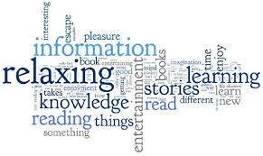Be creative in hosting activities/events to promote a love of reading e.g. introduce favourite authors, poetry, comics days
* Be sensitive and aware that for some people reading may raise anxiety about their own literacy levels
* Have information available on literacy and reading supports in your area
* Connect with your local library and let them know what you are doing – they are part of this initiative and will be delighted to help
* Share your successes, lessons learned and tips with others
* Make sure to join in and read yourself!
* Have fun with it!

**Book Donations Policy**

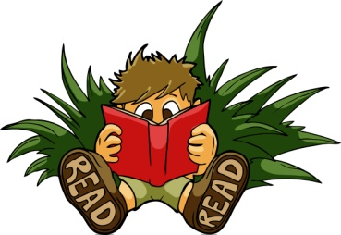The Host Organisation can establish its own policy re donations or use the policy of the CSC Community Book Project. We recommend that a Host accepts donations of items of interest to the public or of special interest categories. Donated items have a cost to the Host Organisations in terms of processing and storage. Because of this, we recommend that they are subject to certain selection criteria:

* Items must be in good physical condition
* Non-book items must be in an accessible and up-to-date format
* Information (Non-fiction) items must be up to date and relevant
* Abridged books are accepted if specifically published for literacy students
* When a donation is accepted, it cannot be returned to the donor

Offers of donations are assessed on this basis, and Host Organisations reserve the right to decline material that does not match these criteria. Donations may also be distributed among the Host Organisations.

***Top Tips...***

* Link to your local library www.donegallibrary.ie – as well as providing books they can give suggestions and advice
* Talk to local community and voluntary groups and book clubs
* Use social media to help with promotion
* Link with the ETB Learning for Living – supports around literacy
* Check in with local schools, community and voluntary groups, parents groups, cafes, about reading/book initiatives they may already be running. Examples include DEAR (Drop Everything & Read); Men’s shed may help construct book corners/shelves; or
* Get involved with Read DL
* Check out ideas like the Free Wee Library at www.freeweelibrary.com or on Facebook

For further information or to get involved contact:

NAME

ORGANISATION / GROUP

ADDRESS

TEL / EMAIL