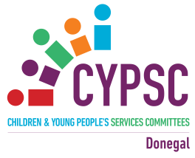
Donegal CYPSC celebrates the launch of Children & Young People’s Plan 2018-2020
With an Information Seminar:
‘Re-imagining Disability, from accepting Diversity to True Inclusion’
Clanree Hotel, Letterkenny, 10th October 2018 9.30am -3.00pm

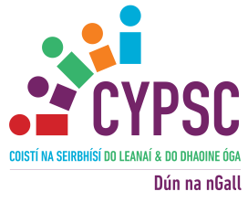
9.30am: Registration, Networking & Viewing of Information Stands Tea & Coffee / Slideshow
Event Chair – Gerry Hone Donegal CYPSC Chair, Area Manager Tusla
10.00: Gerry Hone, CYPSC Chairperson, ‘Welcome Word’
10.10: Dr. Bronagh Byrne, Programme Director (Social Policy), School of Social Sciences, Education & Social Work, Queen's University Belfast. Co-Director Centre for Children’s Rights, Co-Chair Disability Research Network.
10.35: Stephen Barrett, DLDC ‘Profile of Disability in Donegal’
10.50: Anita Gallagher, Manager Physical & Sensory Team & Alvin Doherty, Manager Early Intervention Team HSE ‘HSE Overview of Services’
11.05: Youth Participants, ‘My Journey with help from Foroige’
11.15: Tea & Coffee / Networking & Viewing of Information Stands
- Data Hub demonstration
- Sign up for Disability Awareness Training
- Viewing Photographic Exhibition Donegal Down’s Syndrome
11:45: Examples of Good Practice in County Donegal:
- Wendy McCarry, Bluestack Special Needs Foundation. (15mins)
- Gerry Clark Letterkenny Tennis Club ‘ Sport Inclusion’(10mins)
- Bairbre Cahill, PPFS Tusla ‘Parent Support training’, (10mins)
- Leona Mc Menamin, Mevagh FRC, ‘Parent Support Group’ (10mins)
- Garry Glennon, LYFS, ‘Sensory Santa’ (10mins)
12.40: Bluestack Choir
1.00: Lunch
Event Chair - Liam Ward Donegal CYPSC Deputy Chair, Director of Services Donegal County Council
14.00: Overview Children & Young Peoples Plan – Liam Ward, CYPSC Deputy Chair
14.20: Dr Bronagh Byrne, Launch CYPP
14.30: Closing Remarks - Liam Ward CYPSC Deputy Chair
14.40: Donegal Music Partnership Performance
PLEASE REMEMBER TO FILL IN THE FEEDBACK FORM – Your input is greatly appreciated. Thank you

