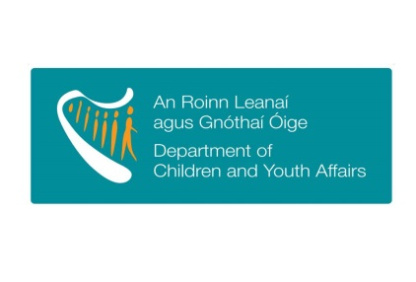

Seed funding towards meeting the objectives of the
Blueprint for the development of Children and Young People’s Services Committees

For the Attention of Chairpersons/Co-ordinators of Children and Young People’s Services Committees

As indicated in the Blueprint for the development of Children and Young People’s Services Committees, the Department of Children and Youth Affairs is committed to resourcing CYPSC through an allocation towards co-ordination costs (in combination with Tusla-the Child and Family Agency and other stakeholders) and through
“financial, administrative or professional supports that will enhance the ability of CYPSCs to support their key priorities and objectives” (Blueprint, pg.28)
In line with this commitment, the Department is prepared to make available a grant to support CYPSCs in meeting the overarching objectives of CYPSC as defined within the Blueprint and having regard to innovative initiatives/activities that align with the key areas of work being progressed under Better Outcomes, Brighter Futures (see Appendix 1&2).
The amount will be from a fixed fund and as such the amount paid out to each CYPSC will be dependent on the total number of applications received. It is estimated to be €20,000- €25,000 per CYPSC. This grant is in place for 2016 only and should not be considered as an ongoing funding stream.
Criteria for use of the grant
The grant is provided to support innovative work as outlined in a CYPSC’s Children and Young People’s Plan (CYPP), and/or to support and inform the development of the Plan.
In particular, it is hoped that this grant, alongside the key increase in the national allocation of CYPSC coordinators, should provide a basis for the delivery of robust, timely plans by those CYPSC who do not already have a plan in place or where a plan is approaching its end.
In considering the use of this grant, CYPSCs will have regard to the following:
- The five National Outcomes for children and young people and/or six transformational goals as set out in Better Outcomes Brighter Futures: the National Policy Framework for Children and Young People 2014 – 2020 (See Appendix 1)
- The key cross-sectoral priorities identified by Better Outcomes, Brighter Futures “Sponsor” Departments (See Appendix 2)
- The need to gather appropriate data to better identify and anticipate needs and recognise trends affecting the child and youth population within the CYPSC’s area.
- That the supported work is cost efficient and does not give rise to any recurring costs. Notwithstanding this it is open to other agencies or organisations on CYPSCs to further invest in this seed funding from their respective funding streams.

Timeframe and reporting
CYPSCs will formulate proposals on the basis that the funding is provided for 2016 and will only be available for activities incurring a cost in the current calendar year.
It will be a matter for successful applicant CYPSC to direct and manage the use of the grant within the overall criteria outlined. In making an application for the grant please use Appendix 3A if your CYPSC is using the funding towards development of your local CYPP and use Appendix 3B if your CYPSC is using the funding to progress actions from within your CYPP under the 5 Outcome Areas or the 6 Transformational Goals. Your CYPSC can apply for funding using both Appendix 3A and 3B if suitable.
CYPSC, to ensure that they have appropriate financial governance structures in place, will be asked to report in detail early in 2017 on how the grant was used including expenditure details.
Grant payments can only be made on receipt of a completed application form provided at Appendix 3A and/or 3B below, along with the reference numbers needed for tax clearance for the relevant account holder.
Please provide all relevant information by close of business on Friday 4th November 2016 marked “CYPSC Seed Funding Application” to:

Policy Innovation Unit
Department of Children and Youth Affairs
43-49 Mespil Road
Dublin 4
E: policyinnovation@dcya.gov.ie
Future provision of grants
It is anticipated that, subject to funding, future funding will be made available to local CYPSC from this Department or other sources to advance innovative initiatives/activities.

Further Information
Queries on the administration of this grant may be directed to the Policy Innovation Unit at policyinnovation@dcya.gov.ie

Guidance on proposals and activities around the use of the grant can be sought from the National Co-ordinator for Children and Young People’s Services Committees at
cniclughadha@effectiveservices.org

Appendix 1 –
Better Outcomes Brighter Futures Transformational Goals and Five National Outcomes for children and young people
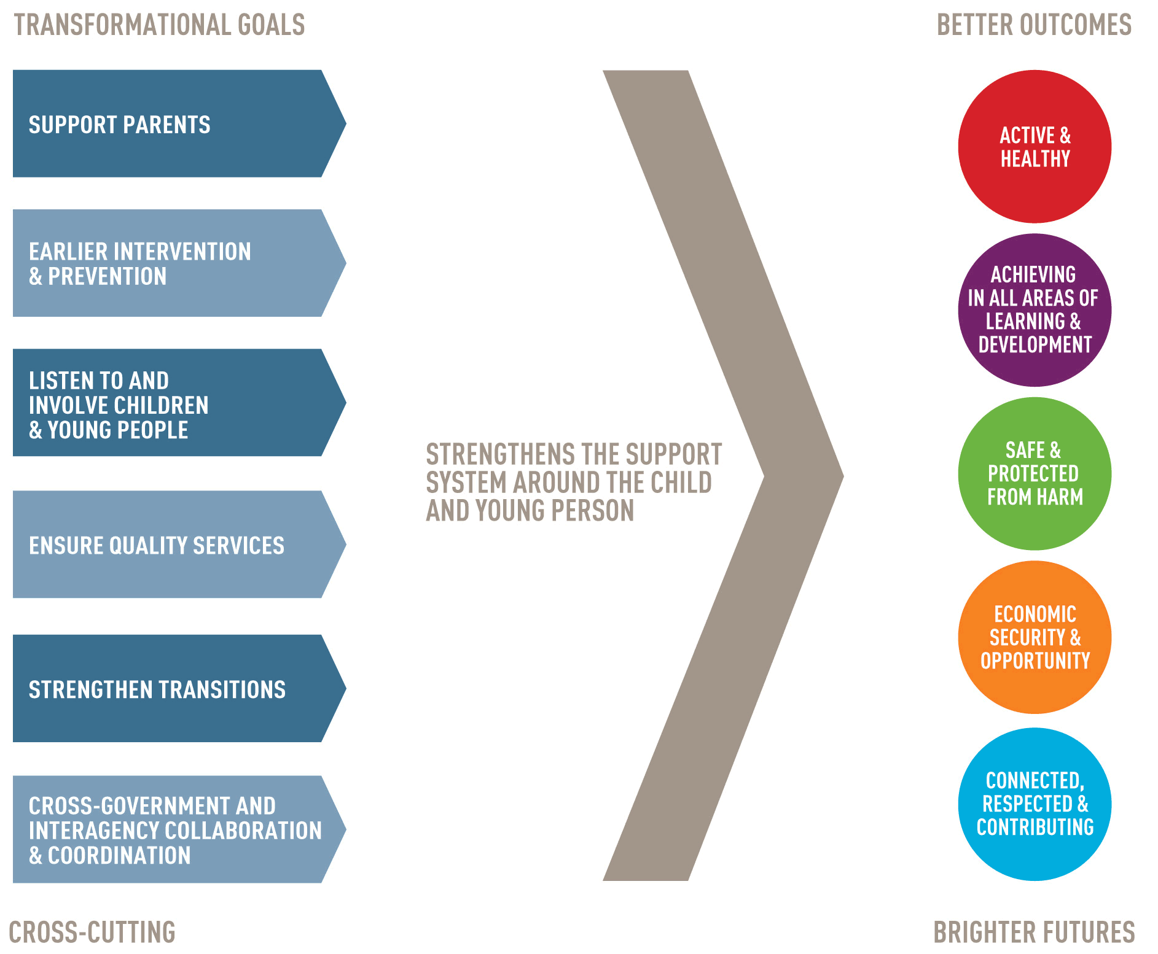
Appendix 2 – Key Cross-Sectoral Priorities and “Sponsor” Department

Lead | Identified cross-sectoral priority
Department of Social Protection | Reducing child poverty
Department of Health | Obesity
Department of Children and Youth Affairs | Enhancing prevention and early intervention
Department of Education and Skills | Review of DEIS
Department of Housing, Planning, Community and Local Government | Homelessness

Appendix 3A-

APPLICATION FOR SEED FUNDING towards meeting the objectives of the Blueprint for the development of Children and Young People’s Services Committees

If your CYPSC wishes to apply for the seed funding towards PLANNING SUPPORTS FOR CYPP please complete this application form:

Name of CYPSC:

Contact details for reply: | Name | Email | Telephone

PLANNING SUPPORTS for CYPP:
Description of Planning Supports:

Outputs:

Budget Breakdown:

Chairperson’s Signature: ______________________________________________________

Date: _______________________________
Please forward this appendix, the completed bank form and the tax clearance reference numbers by close of business on Friday 4th November 2016 marked “CYPSC Seed Funding Application” to: Policy Innovation Unit
Department of Children and Youth Affairs
43-49 Mespil Road
Dublin 4
E: policyinnovation@dcya.gov.ie
Appendix 3B-

APPLICATION FOR SEED FUNDING towards meeting the objectives of the Blueprint for the development of Children and Young People’s Services Committees

If your CYPSC wishes to apply for the seed funding towards project(s) under OUTCOME AREAS please complete this application form:

Name of CYPSC:

Contact details for reply: | Name | Email | Telephone

Five National Outcomes | Tick as appropriate
Active and Healthy
Achieving in all areas of learning and development
Safe and Protected from harm
Economic Security and Opportunity
Connected, Respected and Contributing
Six Transformational goals
Support Parents
Early Intervention and Prevention
Listen to and involve children and young people
Ensure Quality Services
Strengthen Transitions
Cross-government and Interagency collaboration and co-ordination

Supported Action from your CYPP:
Objectives:

Indicator:

Targeted Group:

Targeted Outcome:

…Appendix 3B continued

Activity Description : (Please outline plans for development, process and clearly state how it will feed into the targeted outcomes)

Projected Expenditure Breakdown:

Project Lead (Name and Name of Dept/Agency/Body

Other funding/supports from other bodies:

Chairperson’s Signature: ______________________________________________________

Date: _______________________________
Please forward this appendix, the completed bank form and the tax clearance reference numbers by close of business on Friday 4th November 2016 marked “CYPSC Seed Funding Application” to: Policy Innovation Unit
Department of Children and Youth Affairs
43-49 Mespil Road
Dublin 4
E: policyinnovation@dcya.gov.ie

To be completed by account holder (BLOCK CAPITALS)

I, _________________________________________, authorise the Accountant, Department of Children & Youth Affairs to make payments to [insert name of CYPSC below]

by way of Electronic Funds Transfer (EFT), and in order to facilitate the transactions, I agree to provide the Department with the information requested below:

Bank Name: ___________________________________

Bank Branch Address ___________________________________

Bank Sort Code: ___________________________________ (6 digits)

Bank Account No: ___________________________________ (8 digits)

IBAN Code: ___________________________________ (22 alphanumerics)

BIC Code: ___________________________________ (8 -11alphanumerics)

Name on Account: ___________________________________

(All of these details will be shown on your bank statement)

Please forward the Tax Registration number and the Verification Access Code to enable us to verify the tax clearance of the Account holder with Revenue Commissioners.

Signed:
Position:
Date:

