Confidential & free Sexual Assault Response Services in Ireland

Rape Crisis Centres
22 April 2022

A rape crisis centre is a holistic, safe space where you can find help to heal from trauma after sexual violence of all kinds, including rape, sexual assault, sexual harassment or childhood sexual abuse. This includes counselling and therapy, as well as practical crisis support and information.

Dublin Rape Crisis Centre (DRCC) is one of 16 rape crisis centres around Ireland – information on these is below. Dublin Rape Crisis Centre operates the National Helpline.

Freephone National 24-hr Helpline 1800 778888
This is a listening and support service for anyone who has been affected by sexual violence, whether recent or in the past. It is free and confidential.
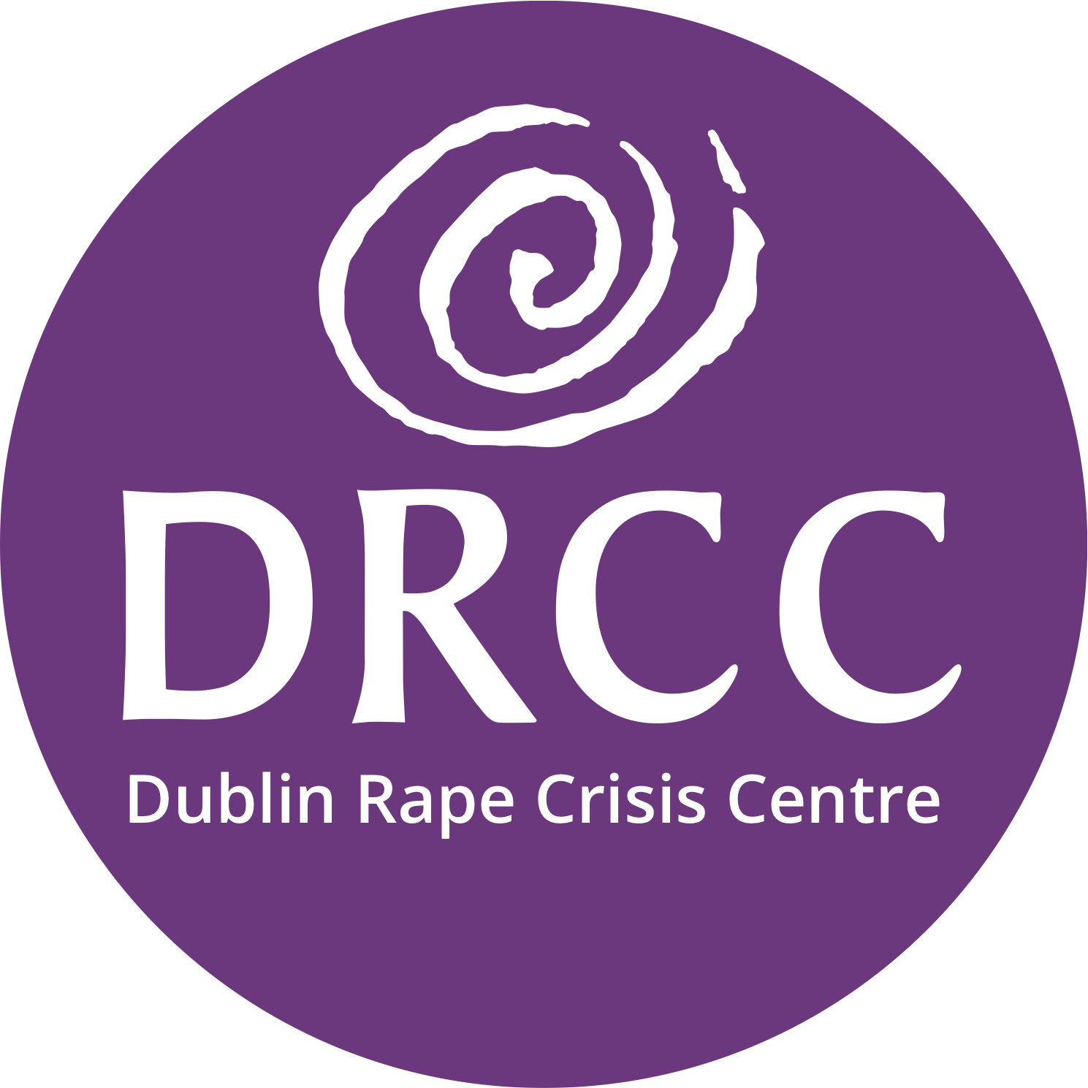

It is also available for people supporting survivors, like friends, families or frontline workers, who need guidance on how to help or who may feel traumatised themselves. We do not record our calls and we do not pass on any information, except where the law requires it for child protection.

You can telephone the National 24-hour Helpline at 1800 77 8888, at any time of day or night (outside of office hours, the line is only able to provide help in English). You can email us at counselling@rcc.ie.
- For those who do not speak English, we offer an interpreting service on the helpline, Monday-Friday (except public holidays), from 8am to 6.30pm. This provides direct interpretation in more than 200 languages, including Ukranian and Russian, over the telephone.
- If you speak English, you can also use our webchat support service, this is online at www.drcc.ie Monday to Friday, 10am to 2pm.
- We have some basic information resources aimed at helping survivors to cope with trauma, which may be useful, on our website at www.drcc.ie. These are in English but you may be able to use the Google translate option.
- For people in the wider Dublin area, we offer a survivor accompaniment service. A trained Accompaniment Support Worker can support you at the Sexual Assault Treatment Unit in the Rotunda Hospital, or with reporting a sexual offence to An Garda Siochana (Police) and attending court.

You can visit our website at www.drcc.ie for information on all our services.

We will listen, we will support you and we will believe you.

DRCC is one of 16 rape crisis centres around Ireland. Our office is in Dublin. If you need to access a centre in other locations, details are at https://www.rapecrisishelp.ie/

For children affected by sexual violence, you can contact CARI – visit https://www.cari.ie/ or call the CARI Care Line at 0818 924567, Mon-Fri, 9am to 5pm (English only)

Sexual Assult Treatment Units (SATU)
21 April 2022
A Sexual Assault Treatment Unit (SATU) is a safe, free and confidential place to go if you have been raped or sexually assaulted. We help anyone who has had unwanted sexual contact of any kind, by providing specialist medical assistance following sexual assault or rape. We are available 24 hours a day, 7 days a week, 365 days a year, in 6 locations across Ireland.
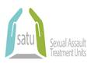
The SATU service offers you a choice of care options according to your needs and preference:

A Forensic Clinical Examination

This is a type of exam carried out to collect evidence following a sexual assault or rape. We can take forensic samples up to 7 days after a rape or sexual assault.
A Health Check
Health checks can involve:
- Examining, treating and documenting any possible injuries
- Providing medications to protect against sexually transmitted infections
- Providing emergency contraception to prevent pregnancy
- Organising a sexual health test. We will offer you a health check whether you decide to have a forensic exam or not.
Our team includes:
- an experienced nurse, midwife or doctor who is trained as a forensic examiner
- support staff (a nurse, midwife)
There may also be:
- a volunteer from a Rape Crisis Centre. They can support you during your visit, in total confidence
- a member of An Garda Siochana (Police) - only if you would like them to be there.
Please visit our website at www.hse.ie/satu for further information on our free confidential service.

