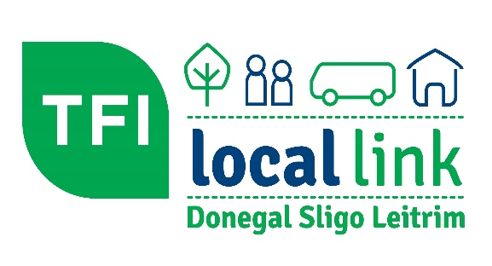

Provision of Transport for Ukrainian Refugees
TFI Local Link and the NTA are making available additional funding for transport to meet identified need. This need will be assessed in a number of categories

- Additional of existing local link services and/or new Demand Responsive and Scheduled Services (DRT & RRS)
Local Link DSL may be in a position to introduce additional stops (subject to approval from Local Authority), additional trips and days of service on existing routes considering the demand from refugee centres.
Some locations housing a large number of refugees in remote areas with no current transport provision or where the numbers would overwhelm current transport provision may require additional services for a short time specific period.
These services where possible should be utilized for accessing English classes and any other services refugees may need to access.
New services and/or additional stops etc. will be reviewed on an ongoing basis as we are aware situations, locations and numbers can change overnight.
To be clear, funding for these amendments and new services will be withdrawn when either of the following conditions arise: -
- Demand drops, i.e., refugees are re-assigned elsewhere or
- When the introduction of other new or enhanced services meets the need.
Requests for additional stops or services must be made through a recognized agencies – examples but not limited to:
Development Companies/Leader Companies
Education and Training Bodies
Inter-Agency working groups
Local Authority.
Requests will not be taken from volunteers or individuals.
Only passengers presenting a Free Travel Pass or who is under 5 will be permitted to travel free, all other passengers must pay relevant fare. Free/Prepaid tickets are no longer valid and there will not be any new tickets issued.

- Community/Once Off funding
Community/Once off funding is being made available where the result of lack of transport, refugees are excluded from events that would promote social inclusion. It is not intended to be used as replacement for regular public transport services.
These ad hoc trips should be co-funded (50%) by state stakeholders or facilities where possible, but there is flexibility to provide 100% funding under certain conditions.

    - Information Days
    - Meet & Greet Events
    - Employment and Job Fairs
    - Intercultural events
    - Community Welcome Days
This funding is not intended for use as a regular public transport service and should be for transport that is once off and is not permanent. Services should only cover refugees and is provided on the basis outlined below:
- The transport service is a once off
- The transport service will increase the quality of life for those availing of the services.
- Service is to cover Ukrainian refugees in need of support and to facilitate social inclusion
- Funding to be provided only where a transport service is needed by a group and cannot be provided in any other way
- The transport service to be provided by the TCU directly through a registered transport operator.
- Does not replace transport services that would expect to be independently funded (e.g. school trips, sports club outings, private parties etc)
- The funding of this transport does not relate to any activity/support beyond the provision of transport services.
Local Link DSL is required to procure transport services from its framework of transport operators, so a minimum of 72 hours is required to organize transport. All service provision is reported to the National Transport Authority (NTA) on a weekly basis thus the following information is required when requesting transport:
- Date and time of transport requested
- Details of trip/event
- Information ono why service and only be provided by community funding
- Details of all stakeholders
- Information on Co-funder and amount of Co-funding
As with “Additional or Existing TFI Local Link Services”, requests for community funding must be made through a recognized agency - no requests will be taken from volunteers or individuals.

Going forward mainstream transport will be reviewed in line with Connecting Ireland to assess need and respond as appropriate.

School Transport
As the provision of closed school transport services is not under the remit of the NTA, no funding is available for this. Queries regarding school transport should be forwarded to relevant school principal who will liaise with DoE or relevant agency

Contact details
TFI Local Link Donegal Sligo Leitrim Offices
Donegal Sligo/Leitrim
Claire Campbell John Carr
Donegal@locallink.ie sligoleitrim@locallink.ie
087-9567484 087-3749943
074-9741644 071-9145828

Appendix One:
TFI Local Link - Community/Once off Funding Approval Form

TCU Donegal Sligo Leitrim

Group Name _________________

Date/Details of Transport Request

Criteria for approval of Community/Once off Funding – all criteria must be met
Criteria | Yes | No
The transport services are once off

Services are to cover refugees in need of immediate support and to facilitate social inclusion
Transport service is needed by a group or individual and cannot be provided in any other way.
The transport service to be provided by the TCU directly/through a transport operator
Does not replace transport services that would expect to be independently funded
Increases quality of life for those availing of the services

The funding does not relate to any activity/support beyond the provision of transport services

Details of Trip, Stakeholders and Third party co funding

For Local Link Use Only
Total Cost €
Third Party Contributor Name
Third Party Contribution €
Net Cost to NTA €
Operator
Set up in ITMS
Approval Section
Name of TCU Manager
Signature
Date
TFI Local Link Programme Manager
Name
Signature
Date

