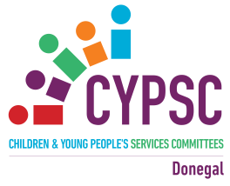
Donegal Children & Young People’s Services Committee
Celebration of Achievement Event, 27th April 2017
Report of participant feedback

Attendees were asked for feedback on the following:
- Did the Celebration of Achievement Event meet your expectations? 97% said Yes

- Did this event increase your knowledge and awareness of Donegal CYPSC? 97% said Yes

- Did this event increase your knowledge of the services and supports to Children & Young People available in County Donegal? 100% said Yes

- What asked to rate the venue
69% said Excellent
26% said Good
5% gave No Comment

