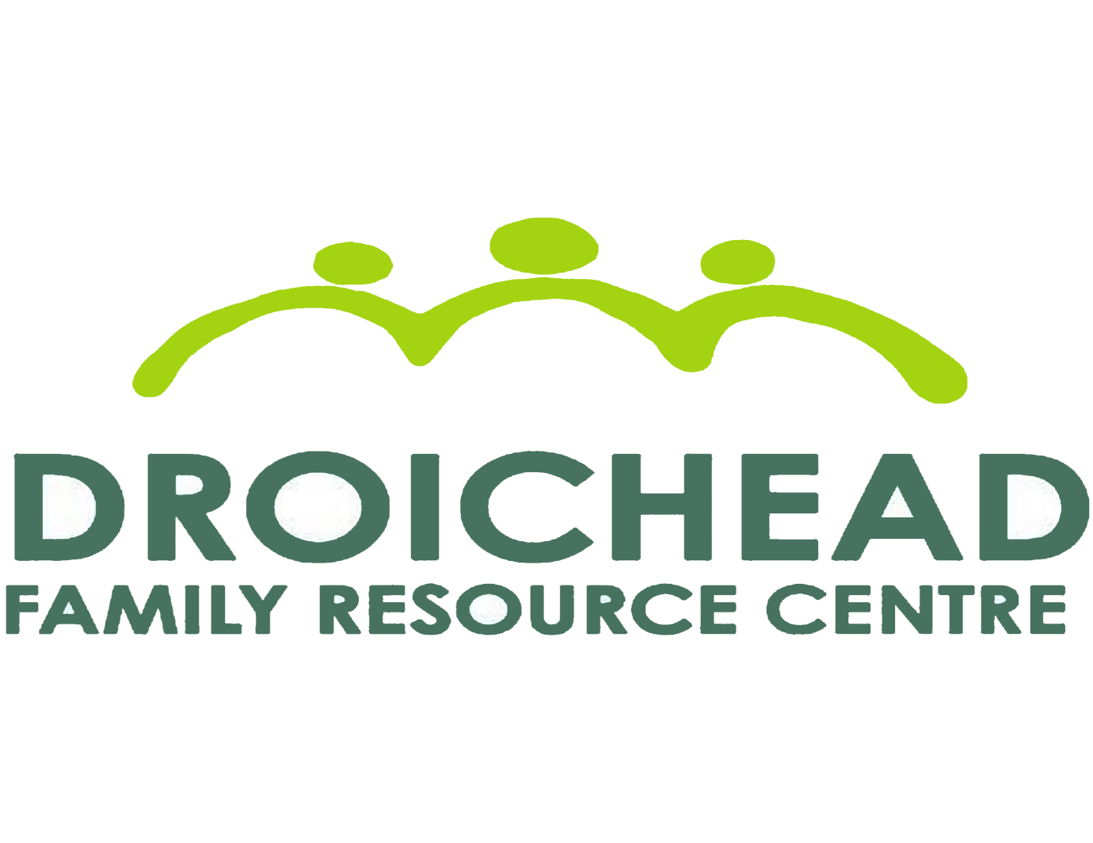
Healthy Streets Programme 2023

Description of project:
A ten- week health and well-being programme for parents and children .The programme was co-ordinated by Health Facilitators who worked with and supported the parents/ guardians and children to engage and participate in the programme. Once a week the parents/ guardians took part in the ‘Cook It’ programme (practical, healthy family meals) with our facilitator Jess. The whole family also participated in physical health and well-being workshops once a week that promote family relationships and learning new exercise skills for undertaking as a family both outdoors and indoors with our facilitator Shane.

Recruitment :
The centre identified 9 families that were already engaged in services in Droichead FRC and would benefit from the programme. 8 out of the 9 families that took part in Healthy Streets were from one parent families. The children taking part in the programme were aged 3-15 years old.

Physical Health & Well- Being :
The families were welcomed to the Healthy Streets programme on a cold frosty Tuesday night in January. Our health facilitator Shane did a health screening with all families before taking part in the exercise class. The families spent the majority of classes with Shane outdoors where possible and classes were adapted when taking place indoors.

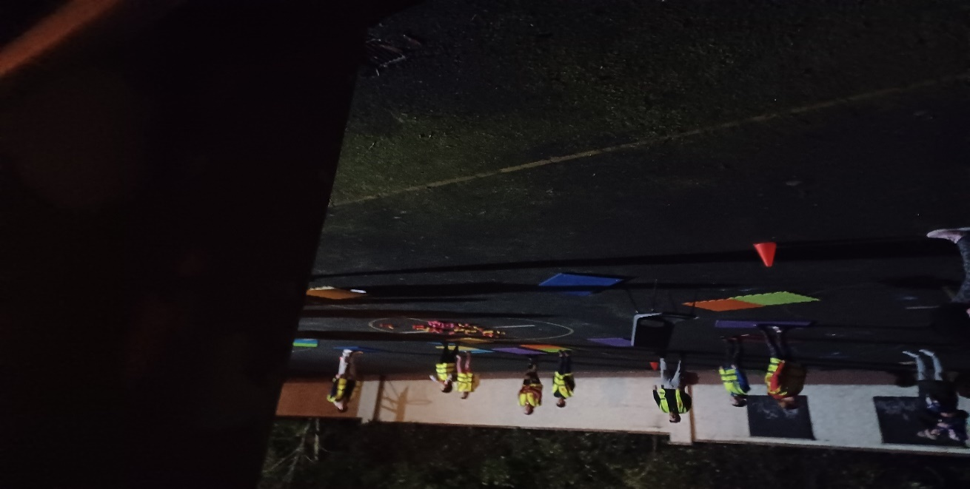
Where it started.
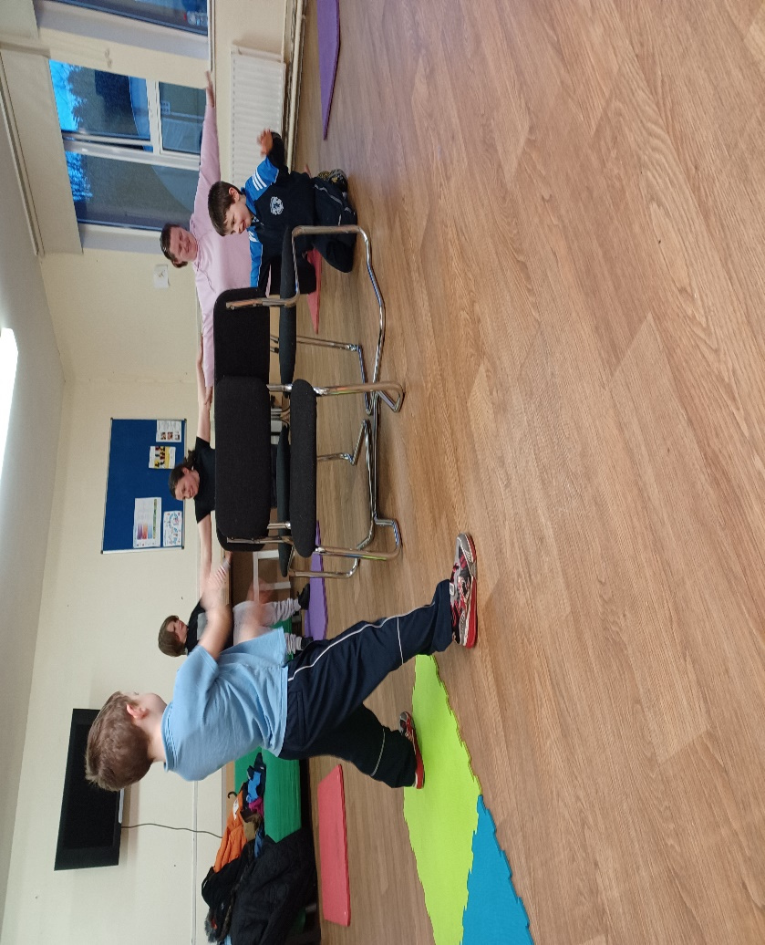
Friendly competition Musical Chair’s.

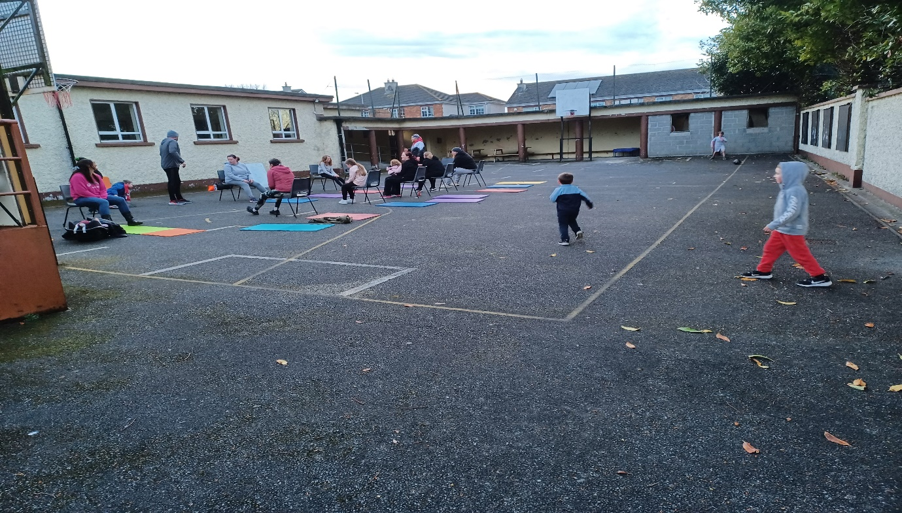

Chair Based Exercise, moving to mat exercises.

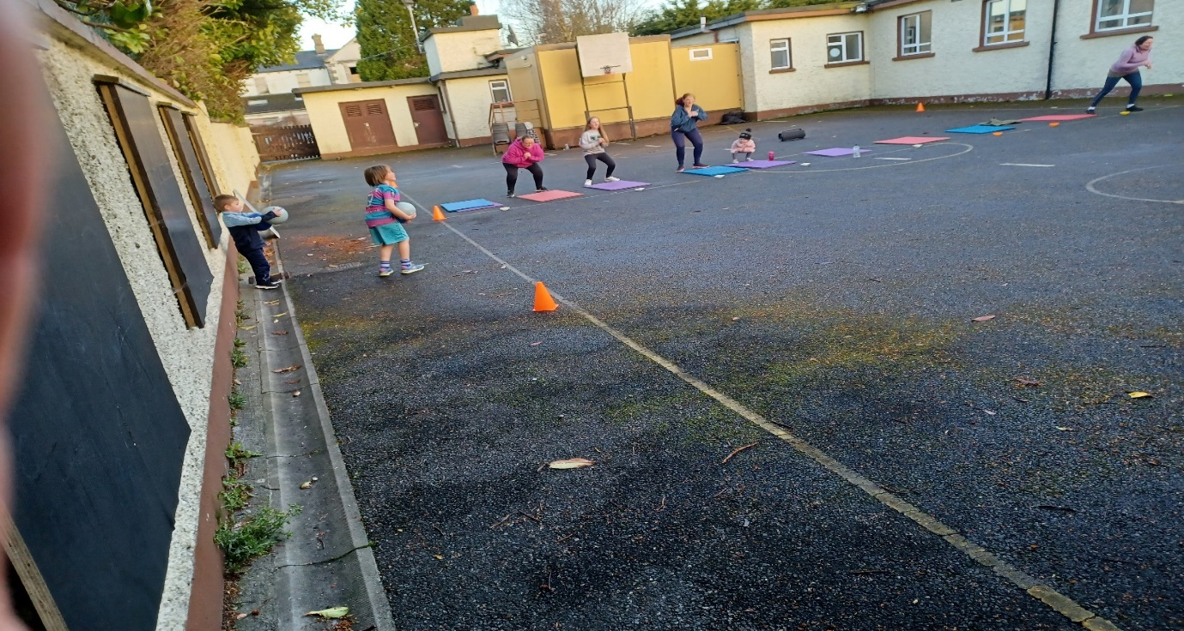
Parent Dodgeball- the most requested game from the children.
The main emphasis of the classes were active participation of all families and fun. As the weeks went on families noted the many benefits they were feeling from class such as feeling stronger, increasing reps each week, more restful sleep for the whole family and moving more as a family outside of class. As the weeks progressed the families naturally developed peer support and cheered and pushed each other on during team games and individual goals. Shane noted the families progress also and commended them for their participation and attendance each week even when the weather was poor.
The families received a fleece lined bobble hat for each participant to keep warm while exercising outdoors.
Cook It :
Our facilitator Jess supported parents/ guardians by providing them with hands on practical experiences of cooking and preparing food and providing practical advice and information on healthy eating and food safety. The families received a cook book “101 Square Meals- Easy recipes for everyday life” and were able to plan what food group they would be focusing on the following week and what dish they would cook and the ingredients required, tailored to dietary requirements. As participants progressed through the programme it was noted the participants had grown in confidence in the kitchen especially the 3 men in the group.
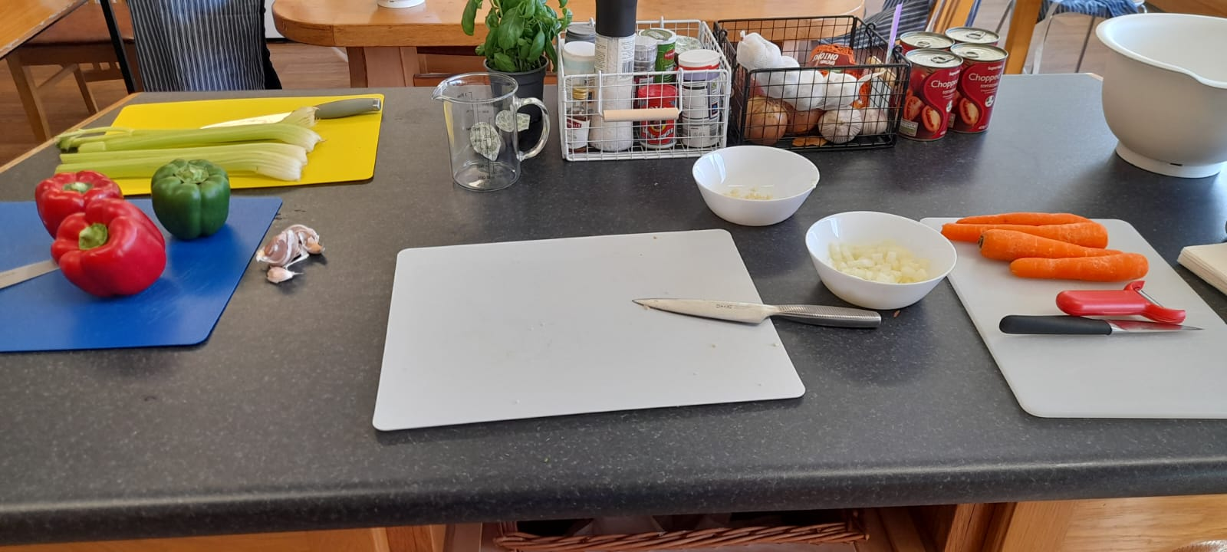
Food preparation.
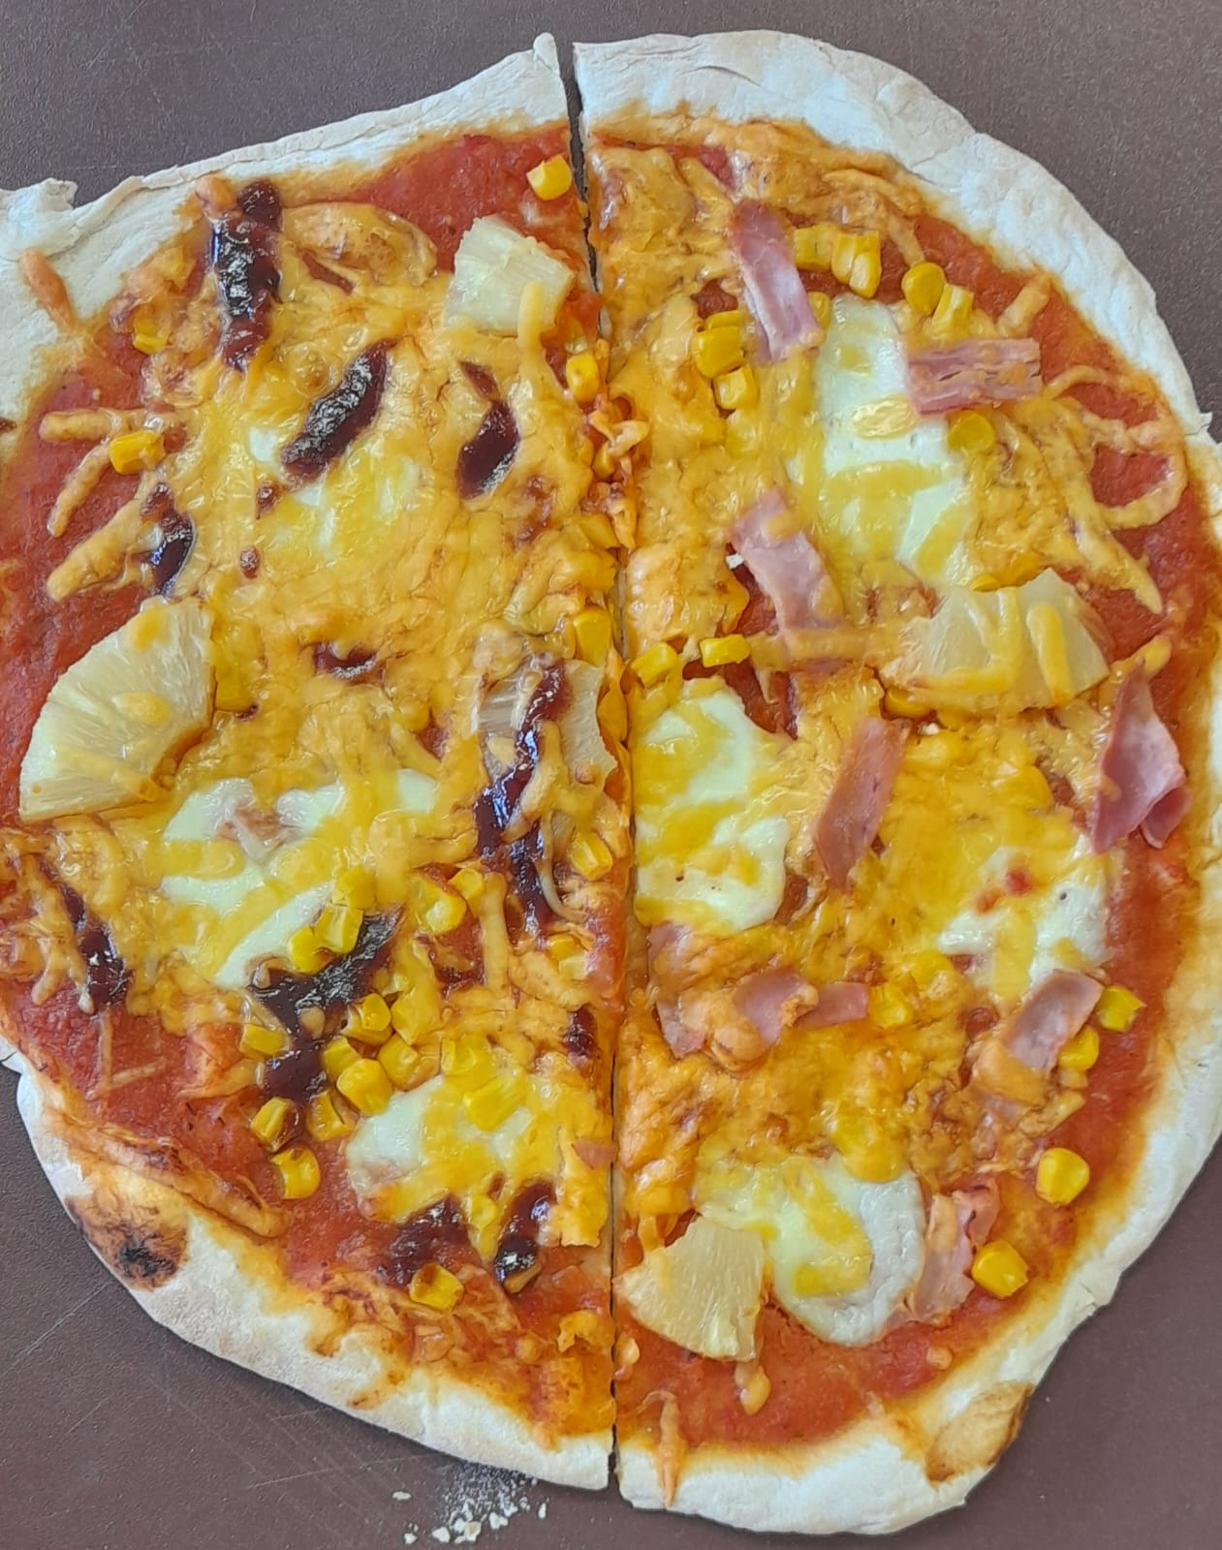
Healthy pizza’s – Fakeway
The families really enjoyed making fakeways as it is a heathy alternative to a take away. In the Healthy Streets Wats app group families sent in what they made at home with their children. This programme wasn’t just about cooking and nutrition it supported and informed parents/ guardians in ways the whole family could be included in meal prep, cooking, portion control and budgets.
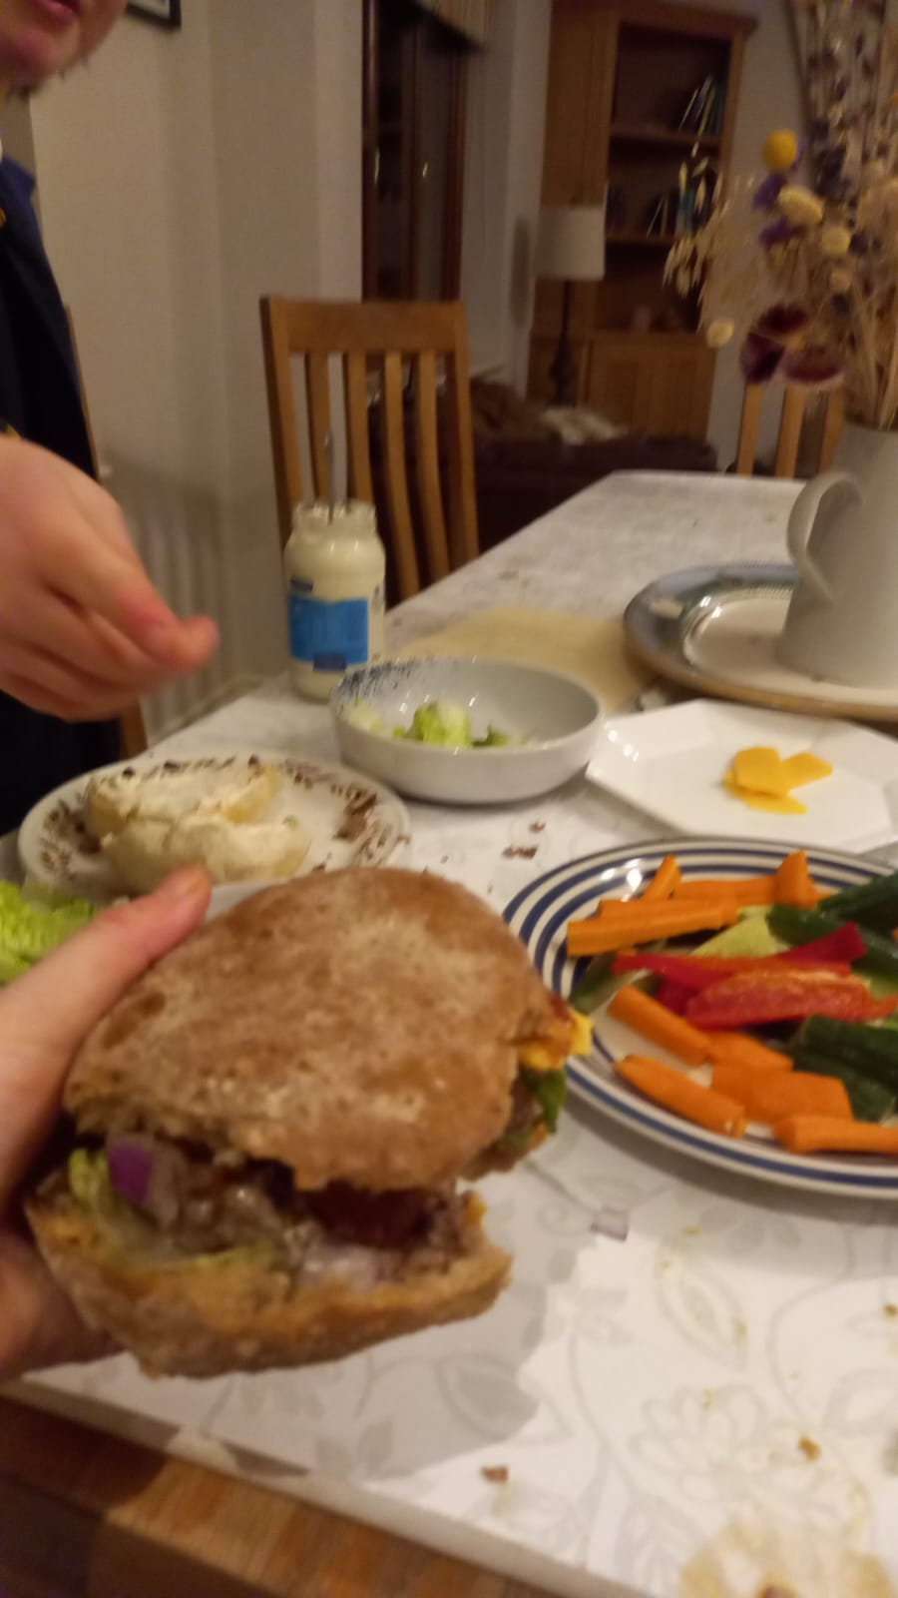
Tasty Fake way at home.
Attendance:
Overall there was good attendance throughout the programme. One family could not complete the programme as it was not the right time for them to commit to attend classes .
Vouchers :
Each week families who attended physical health and wellbeing class and the cook it programme received a €30 voucher for supermarkets in Callan. It appeared this was a good incentive for families and there was a high rate of attendance most weeks during the programme. Vouchers for family days out such as bowling, swimming and Castlecomer Discovery Park were also on offer to families for their active participation in the programme.

Outcomes:
- Vouchers for groceries were wisely used and assisted families in the rise in cost of living crisis.
- Participants availed of other services in the centre such as counselling and groups.
- Good rates of attendance was observed.
- Participants volunteered in the Family Resource Centre.
- Participants availed of Droichead FRC Food Bank.
- Peer support and getting to know other parents in the community.
- Healthy Streets families have started to grow their own produce in the community garden.
- Participants have a good relationship with their local family Resource Centre.
- Families would like a follow up to this programme.
- Families have learned practical lifelong skills that can be passed on and shared with future generations and other members of the community.
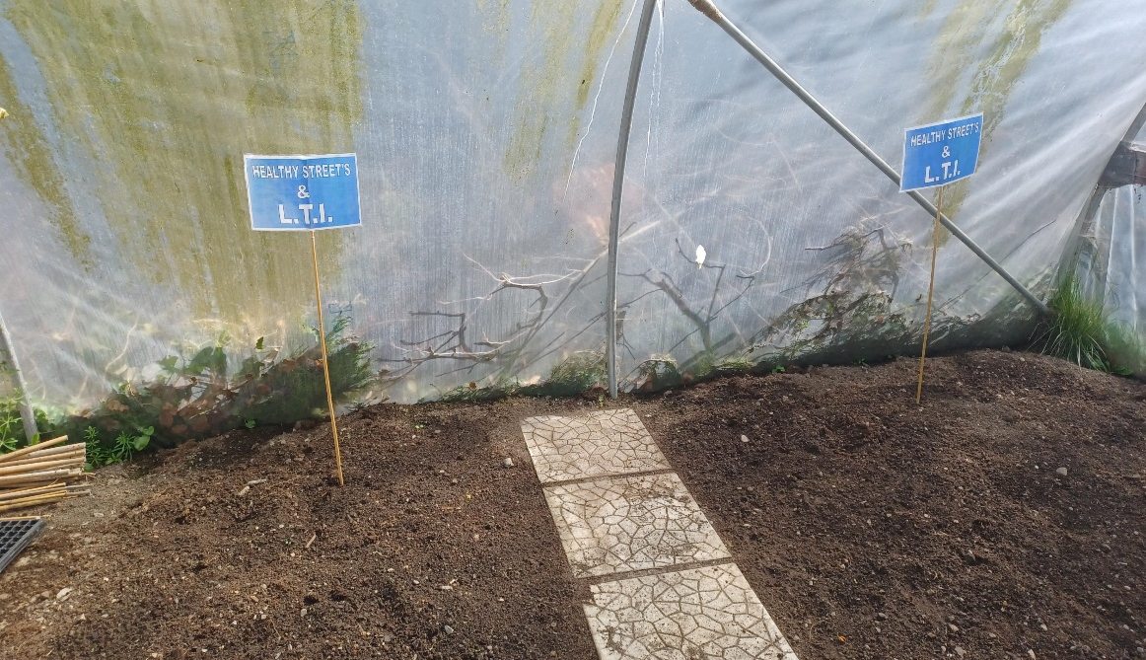

Future Healthy Streets Programme:
The feedback we received through anonymous online questionnaires from participants and facilitators will inform future programmes.
Participants
- More time to be allocated to Cook It programme for class.
- A class where children can come in and cook with their parents/ guardians.
- Healthy Streets participants family outing with facilitators.
- The programme to run for 12 weeks.
Facilitators
- More time to be allocated to Cook It programme for planning and class.
- Budget to include purchasing of kitchen equipment.
- Facilitators meeting prior to programme commencing.

Feedback from families:
“ I came for the vouchers I didn’t think I would have learned and enjoyed this as much”
“It’s not that hard to cook but it is easier when you know how”

“What can I do next ?. I feel more confident and I have lost 8 pounds since I started”
“I have a jumper that didn’t fit me for the last 2 years that fits me now. Don’t look at the scales, judge it by your clothes”

“I have signed up for a Pilates class to keep me going”
“I love the chats we have at class and the end of class party”

