Terms of Reference for Co. Clare
Children and Young People’s Services Committee

Purpose
The purpose of the Co. Clare Children and Young People’s Services Committee will be to provide strategic direction and leadership to ensure effective interagency co-ordination and collaboration in order to achieve the best outcomes for all children and young people in Co. Clare.

The Five National Outcome areas for children and young people in relation to the six transformational goals set out in the ‘Better Outcomes, Brighter Futures’ national policy framework document are:

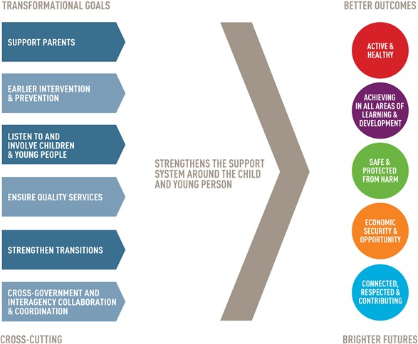

OBJECTIVES:

The Co. Clare CYPSC objectives are to bring together relevant statutory, community and voluntary organisations providing services to children and young people to maximise the reach, coverage and impact of such services through:

- Ensuring that the needs of children and young people are identified and addressed
- Planning and co-ordination of services
- Ensuring effective collaboration and interagency working
- Promoting quality, evidence-informed planning and practice
- Optimising the use of resources
- Promoting best participation practice

The Co. Clare Children and Young People's Services Committee will develop and oversee the implementation of a three-year Children and Young People’s Plan (CYPP) for Co. Clare that is designed to improve outcomes for children and young people.

Term

These Terms of Reference are effective from 3RD April 2018 and continue until the 3RD April 2019

Membership
Co. Clare CYPSC will comprise:
  - Caroline Cullen, Acting Area Manager, Tusla (CYPSC Chairperson)
  - Damien McMahon, Housing Dept. Clare Co. Council (CYPSC Vice-Chairperson)
  - Sinéad Collopy, CYPSC Coordinator, Tusla (CYPSC Co-ordinator)
  - Áine Mellett, PPFS Manager, Tusla
  - Sian Harris, Senior Clinical Psychologist, H.S.E
  - Teresa Crawford, Psychological Services Manager, LCETB
  - Christine O’Sullivan, Senior Educational Psychologist, NEPS
  - Jacinta Swann, Family Support Services Manager, Clarecare
  - Kees Duson, Family Resource Centre representative, Killaloe/Ballina FRC
  - John Ryan, Inspector, An Garda Siochana
  - Margaret Slattery, C.E.O Clare Youth Services
  - Maria Tobin, Senior Manager Education and Welfare Services, Tusla
  - Darren Broomfield, Senior Probation Officer, Probation Services
  - Karen McCarthy, Coordinator, Clare County Childcare Committee
  - Ann Callaghan, HR Manager, Clare Local Development Company
  - Sharon Dilger, Principal, IPPN
  - NAPD ( to be filled )
  - Youth rep ( to be filled )

- Roles and Responsibilities

The Clare CYPSC is an interagency committee whose overall purpose and function is to secure better developmental outcomes for children and young people by:

- Coordinating the implementation of national and regional policies and strategies that relate to children, young people and families

- Support national initiatives that involve children and young people in decision making on the development and delivery of children and young people’s services

- Bringing together and establishing mechanisms for communication between, statutory, community and voluntary organisations involved in providing services to children and young people

- Developing and overseeing the implementation of an inter-agency Children and Young People’s Plan (CYPP) designed to improve outcomes for children and young people by completing the following:

- Conducting needs analyses relevant to the specified national outcomes for children and young people and other relevant local issues

- Identifying gaps and priorities in relation to population groups and services in the area

- Put in place monitoring and evaluation arrangements for the CYPP

- To bring partners together within a single framework for the delivery of services to children, young people and their families within Co. Clare.

- To provide strategic leadership to ensure the development of and delivery of improved outcomes for children, young people and their families.

- To oversee the administration of funding made available to the Clare CYPSC in alignment with the CYPP and also act as a partnership consortium should other avenues of external funding become available.

- To highlight to relevant national bodies potential threats to existing services which may have a detrimental effect to delivering positive outcomes to children and families in Clare.

- To act as a support to the CYPSC Coordinator in offering guidance, direction and facilitating information requests where necessary, in regard to the delivery of the CYPSC agenda.

- To promote CYPSC work using an agreed Quality Framework, ensuring the coordination of the work is utlising an evidence base and adheres to best practice principles involving active youth participation.

- Leadership
Leadership on the CYPSC initiative, at a national level, has been provided by the DCYA.
The DCYA designated TUSLA – Child and Family Agency to lead this initiative.
This decision was driven by the fact that TUSLA – Child and Family Agency is responsible for child
welfare and protection and family support services, and has trained professionals to
support the delivery of these services.

Chair of the CYPSC
The Clare CYPSC will be chaired by the local Area Manager of Tusla – Child and Family Agency

The key responsibilities of the Chair include:
• Provide leadership and direction for the CYPSC
• Ensure the effectiveness of the committee in all aspects of its role, including delivery of its CYPP
• Ensure active participation and contributions from all members across all sectors
• Ensure appropriate interaction between the committee and external stakeholders

Deputy Chair
The Local Authority representative is the deputy chair of the Clare CYPSC.
The responsibilities of the vice chair are:
• Support the CYPSC Chairperson in the performance of his/ her duties
• In the case of unavailability of the chairperson at any committee meeting, to take the role of Chairperson for that meeting
• Ensure an appropriate balance between the voice of the Chairperson’s organisation and that of other member organisations

The CYPSC Coordinator
The Clare CYPSC Coordinator will support the CYPSC in its work to bring together a diverse group of
agencies in Clare to engage in joint planning and co-ordination of services for children and
young people.

The key responsibilities of the CYPSC Coordinator include:
• Support the development of the CYPSC and its sub-groups
• Communicate a clear sense of purpose and direction on behalf of the committee
• Foster and develop relationships with key personnel including CYPSC members and other stakeholders within associated agencies/service providers involved in the provision of child and family services

- Meetings
  - All meetings will be chaired by the Tusla Area Manager
  - A meeting quorum will be a third plus one members of the CYPSC.
  - Decisions made by consensus (i.e. members are satisfied with the decision even though it may not be their first choice). If not possible, CYPSC Chairperson makes the final decisions.

  - Meeting agendas and minutes will be provided by the CYPSC Coordinator. This includes:
- preparing agendas and supporting papers;
- preparing minutes/meeting notes and information.
  - Meetings will be held monthly until the launch of the CYPP plan at River House, Gort Road, Ennis.
Meeting frequency will be reviewed again by the committee once the CYPP is operational.
  - If required, sub-group meetings will be arranged outside of these times at a time convenient to sub-group members.

Amendment, Modification or Variation
The Terms of Reference may be amended, modified or varied in writing after consultation and agreement by CYPSC members.

